Buku Panduan & Source Code
Jenis Ciptaan
Perangkat Lunak

Judul Ciptaan
CipherVision
(Analisis Frekuensi dan Visualisasi Cipher Substitusi)


Pencipta :
Daniel Aquaries / A11.2023.15003
Fauzi Adi Rafrastara, M.CS. / 0686.11.2011.398
Arvin Farrel Pramuditya / A11.2023.15062
Ramadhan Rakhmat Sani /

Universitas Dian Nuswantoro Semarang
2025

Daftar Isi
Daftar Isi 2
1. Gambaran Aplikasi 3
2. Manual Penggunaan 4
A. Aplikasi analisis CipherVision 4
B. Aplikasi Enkripsi 6
1). Fitur Utama 8
2). Kebutuhan SIstem 8
3. Source Code Analisis Cipher (analysis_frequent_text.py) 10
4. Source Code Analisis Enkripsi (encrypth_text.py) 10

Gambaran Aplikasi
Tampilan awal aplikasi CipherVision

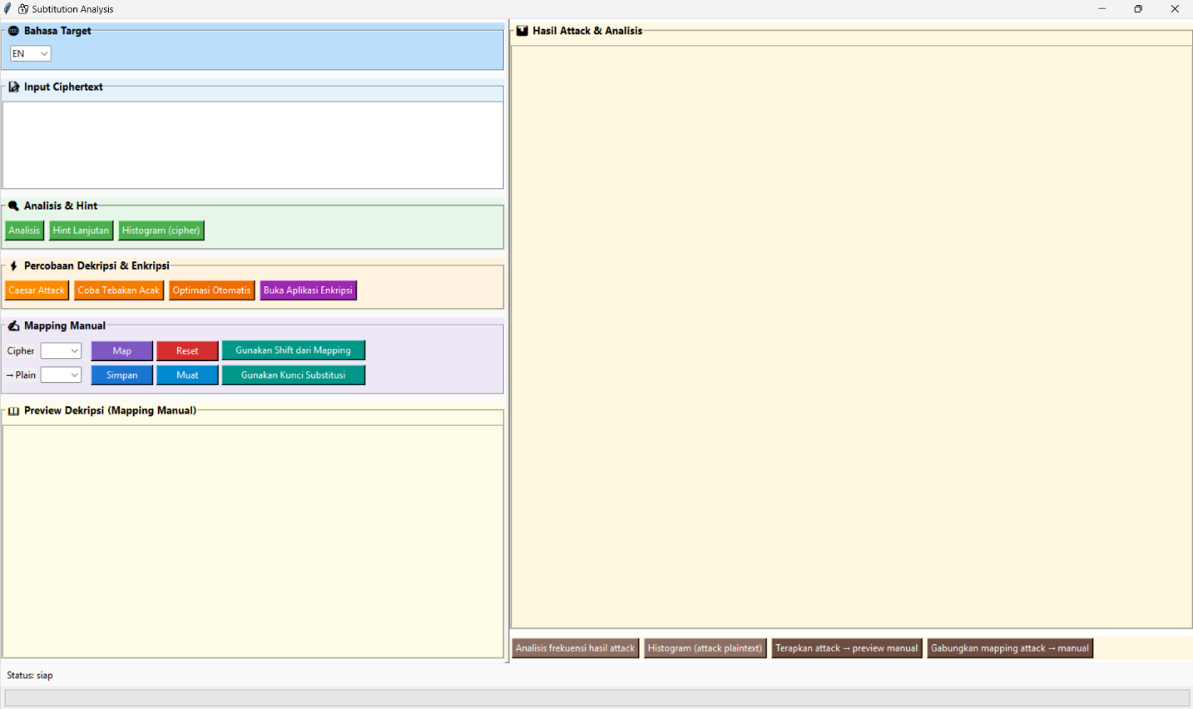
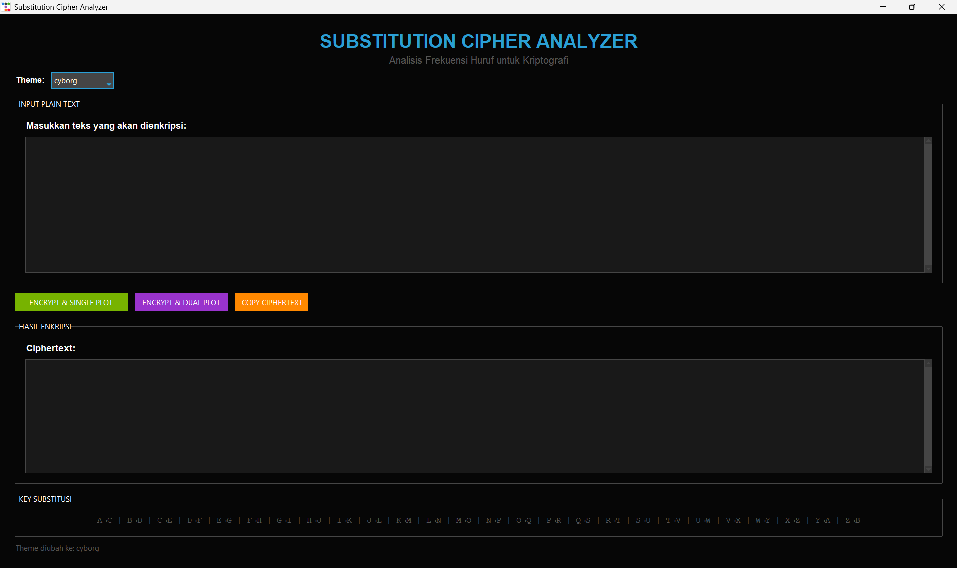

Keterangan :

CipherVision terdiri dari 2 aplikasi terintegrasi:
- Aplikasi Analisis Cipher (analysis_frequent_text.py)
  - Alat dekripsi cipher substitusi
  - Analisis frekuensi huruf
  - Multiple attack methods (Caesar, Random, Auto-Tune)
  - Dukungan bahasa Inggris dan Indonesia
- Aplikasi Enkripsi & Visualisasi (encrypth_text.py)
  - Generator cipher substitusi
  - Visualisasi frekuensi (single/dual plot)
  - Interface modern dengan tema customizable

Manual Penggunaan

Aplikasi analisis CipherVision
- Jalankan: python analysis_frequent_text.py
- Langkah:
  - Masukkan ciphertext di panel kiri
  - Pilih bahasa target (EN/ID)
  - Klik "Analisis" untuk mapping awal
  - Gunakan metode attack:
    - Caesar Attack (otomatis/manual)
    - Random Attack (8000-20000 iterasi)
    - Auto-Tune Attack
  - Atur mapping manual jika diperlukan
  - Hasil muncul di panel kanan

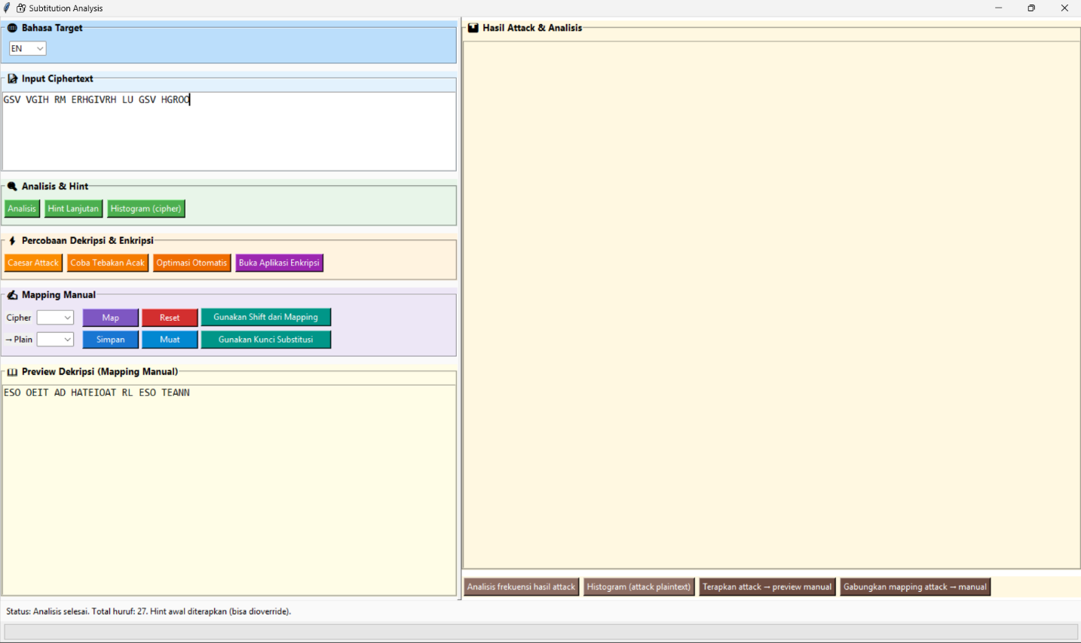
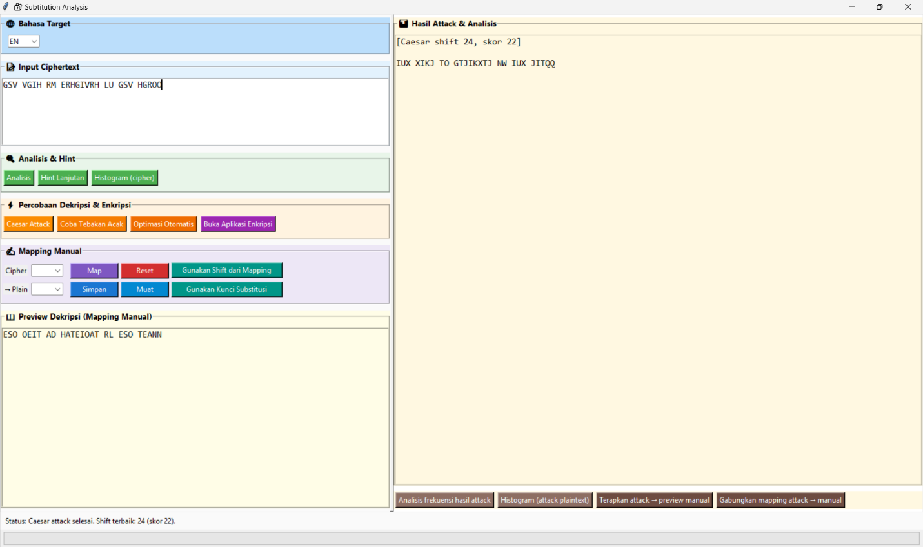
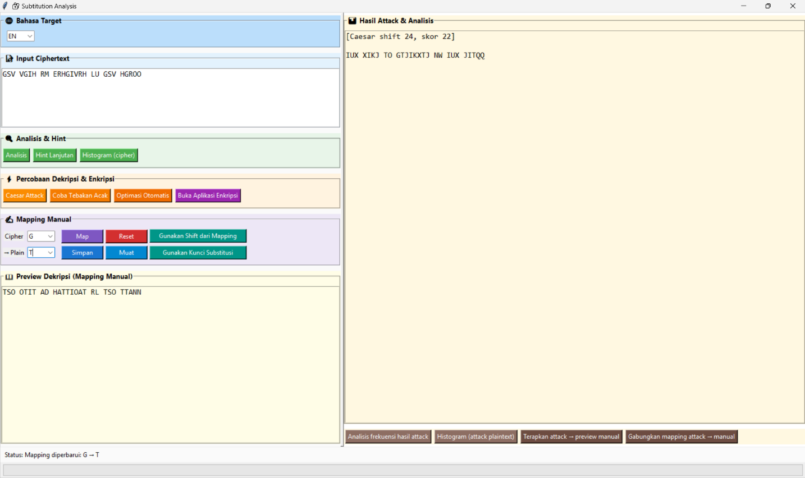
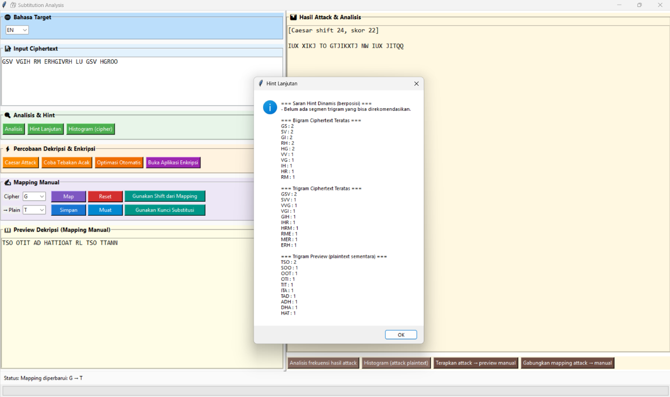
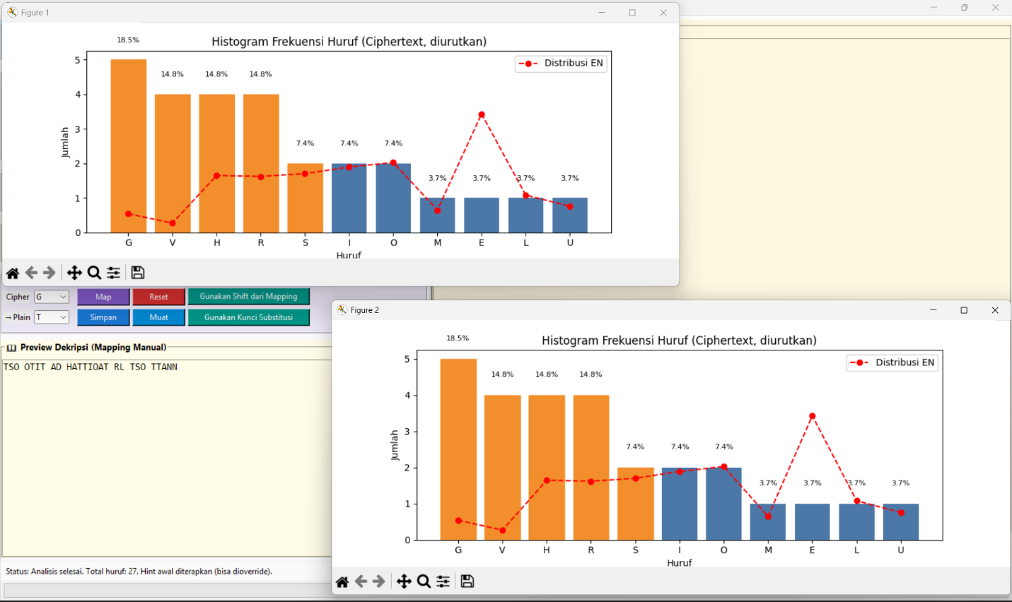

Aplikasi Enkripsi
- Jalankan: python encrypth_text.py
- Langkah:
  - Masukkan plaintext
  - Klik "ENCRYPT & SINGLE PLOT" (grafik gabungan)
  - Atau "ENCRYPT & DUAL PLOT" (2 grafik terpisah)
  - Ciphertext muncul di panel hasil
  - Dapat di-copy ke clipboard

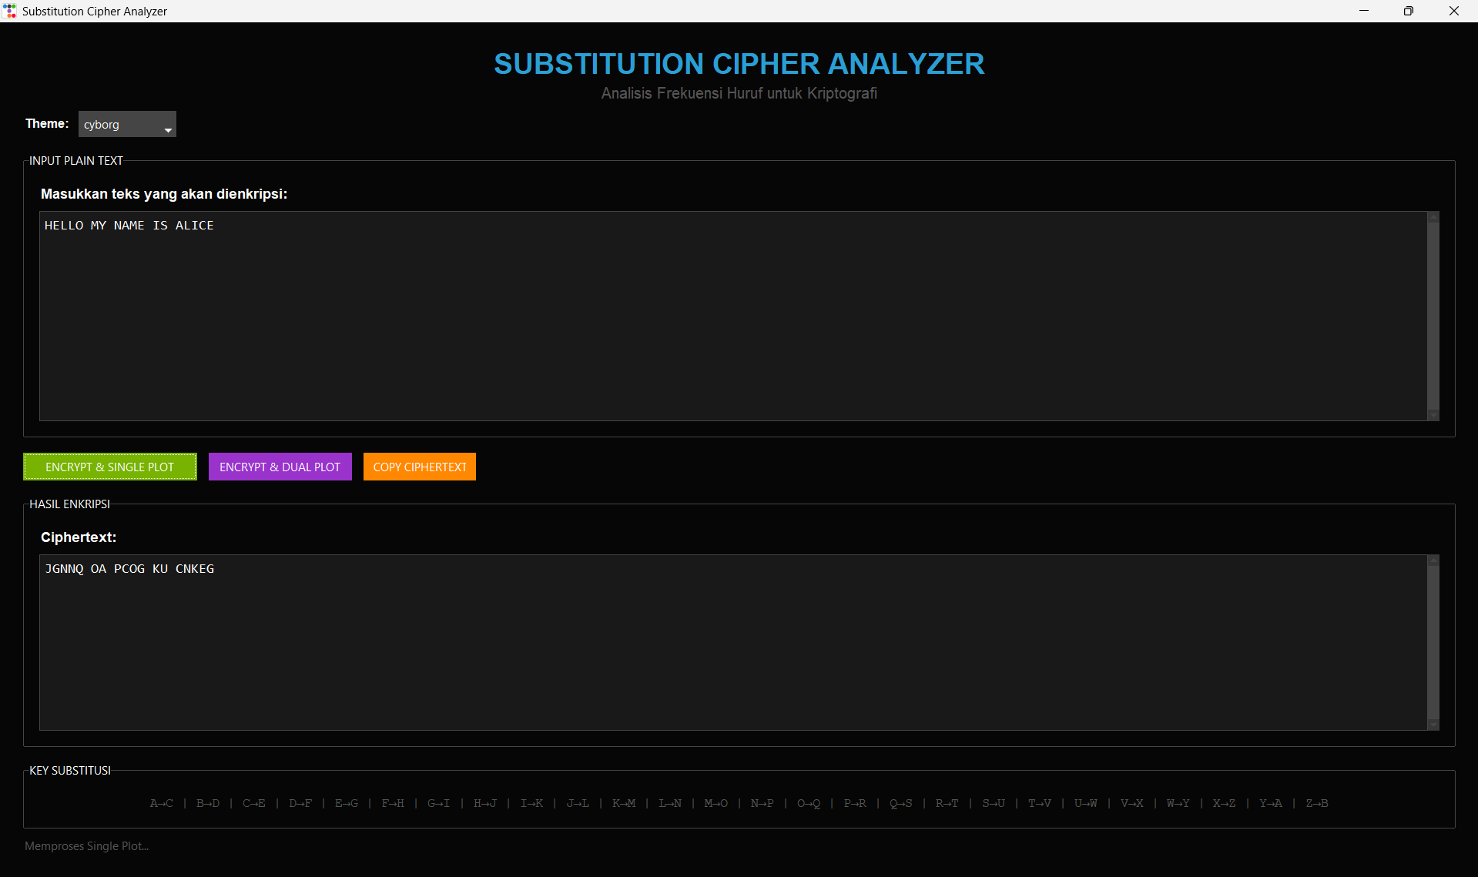
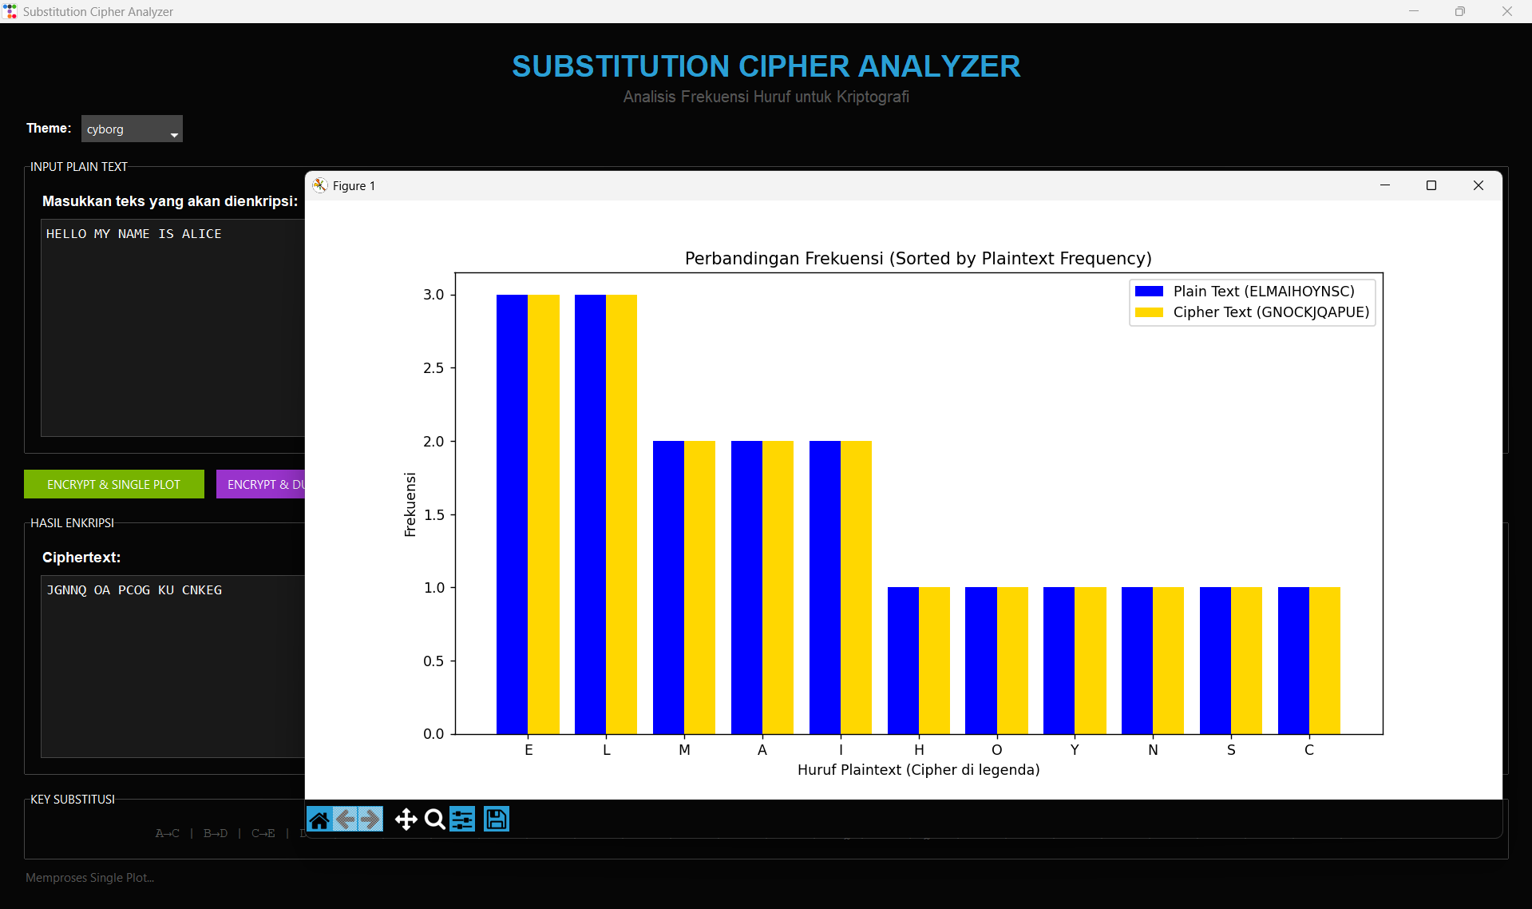
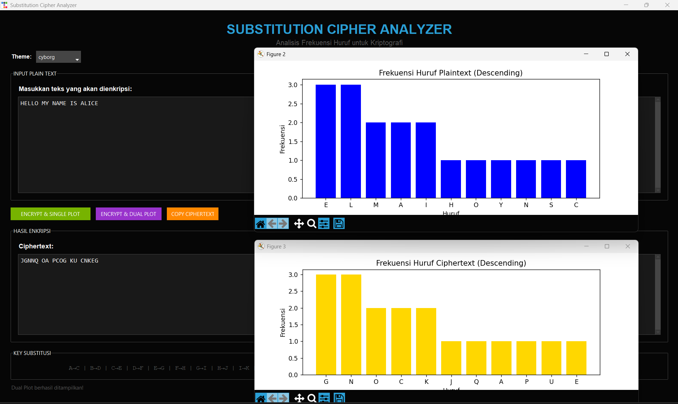

Fitur Utama
- Analisis frekuensi multi-bahasa
- Hint dinamis berdasarkan posisi
- Visualisasi distribusi huruf
- Save/load mapping ke JSON
- Percobaan Dekripsi dengan Caesar dan Tebakan Acak dengan Perulangan
- Integration antar aplikasi

Kebutuhan Sistem
- Halaman Python 3.7+
- Library: tkinter, matplotlib, numpy, ttkbootstrap
- Sistem operasi: Windows/Linux/macOS

Source Code

Aplikasi Cipher Vision (Analisis Frekuensi dan Visualisasi Cipher Subtitusi)

Source Code Analisis Cipher (analysis_frequent_text.py)

- Running App
if __name__ == "__main__":
root = tk.Tk()
app = SubstitutionGUI(root)
root.mainloop()

- Method-Method untuk analisa
def normalize_text(text):
return "".join(ch for ch in text.upper() if ch in string.ascii_uppercase)

def frequency_analysis(text):
norm = normalize_text(text)
total = len(norm)
counter = collections.Counter(norm)
return counter, total

def proportions(counter, total):
return {
k: (counter.get(k, 0) / total * 100 if total > 0 else 0.0)
for k in string.ascii_uppercase
}

def suggest_mapping(counter):
cipher_order = [l for l, _ in sorted(counter.items(), key=lambda x: (-x[1], x[0]))]
suggestion = {}
for i, c in enumerate(cipher_order):
if i < len(ENGLISH_FREQ_ORDER):
suggestion[c] = ENGLISH_FREQ_ORDER[i]
return suggestion

def apply_mapping(text, mapping, unknown_char="·"):
out = []
for ch in text:
up = ch.upper()
if up in string.ascii_uppercase:
mapped = mapping.get(up)
if mapped:
out.append(mapped if ch.isupper() else mapped.lower())
else:
out.append(unknown_char)
else:
out.append(ch)
return "".join(out)

- Analisis Cipher Text
def analyze(self):
self.ciphertext = self.input_text.get("1.0", "end").strip()
if not self.ciphertext:
messagebox.showwarning("Peringatan", "Masukkan ciphertext terlebih dahulu.")
return
counter, total = frequency_analysis(self.ciphertext)
self.hint_mapping = suggest_mapping(counter)
self.update_preview_manual()
self.set_status(
f"Analisis selesai. Total huruf: {total}. Hint awal diterapkan (bisa dioverride)."
)

- Caesar Decrypt
def caesar_decrypt(ciphertext, shift):
result = []
for ch in ciphertext:
if ch.isalpha():
base = ord("A") if ch.isupper() else ord("a")
result.append(chr((ord(ch) - base - shift) % 26 + base))
else:
result.append(ch)
return "".join(result)

def run_caesar_attack(self):
self.ciphertext = self.input_text.get("1.0", "end").strip()
if not self.ciphertext:
messagebox.showwarning("Peringatan", "Masukkan ciphertext terlebih dahulu.")
return

# Tanya user apakah mau input shift manual
choice = messagebox.askyesno(
"Caesar Attack",
"Apakah Anda ingin memasukkan shift secara manual?\n"
"Ya = input manual, Tidak = cari otomatis terbaik.",
)

if choice: # === Mode manual ===
shift = self.ask_shift_with_slider()
if shift is None:
return

preview = caesar_decrypt(self.ciphertext, shift)
self.attack_preview = preview
self.attack_mapping = {}
self.attack_text.delete("1.0", "end")
self.attack_text.insert(
"1.0", f"[Caesar shift {shift} (manual via slider)]\n\n{self.attack_preview}"
)
self.set_status(f"Preview Caesar dengan shift {shift} ditampilkan.")

else: # === Mode otomatis (brute force terbaik) ===
best_shift, best_text, best_score, _ = caesar_attack(
self.ciphertext, lang=self.lang.get()
)
self.attack_preview = best_text
self.attack_mapping = {}
self.attack_text.delete("1.0", "end")
self.attack_text.insert(
"1.0",
f"[Caesar shift {best_shift}, skor {best_score}]\n\n{self.attack_preview}",
)
self.set_status(
f"Caesar attack selesai. Shift terbaik: {best_shift} (skor {best_score})."
)

- Mapping Cipher Text to Plain Text
def update_mapping(self):
c = self.cipher_var.get().upper()
p = self.plain_var.get().upper()
if c in string.ascii_uppercase and p in string.ascii_uppercase:
self.mapping[c] = p
self.update_preview_manual()
self.set_status(f"Mapping diperbarui: {c} → {p}")
else:
messagebox.showerror("Error", "Pilih huruf A–Z untuk mapping.")

def reset_mapping(self):
self.mapping = {}
self.update_preview_manual()
self.set_status("Mapping manual dikosongkan (hint awal tetap ada).")

def save_mapping(self):
if not self.mapping:
messagebox.showinfo("Info", "Mapping manual kosong.")
return
path = filedialog.asksaveasfilename(
defaultextension=".json", filetypes=[("JSON", "*.json")]
)
if not path:
return
with open(path, "w", encoding="utf-8") as f:
json.dump(self.mapping, f, ensure_ascii=False, indent=2)
self.set_status(f"Mapping disimpan ke {path}")

def load_mapping(self):
path = filedialog.askopenfilename(filetypes=[("JSON", "*.json")])
if not path:
return
try:
with open(path, "r", encoding="utf-8") as f:
data = json.load(f)
for k, v in data.items():
if k not in string.ascii_uppercase or v not in string.ascii_uppercase:
raise ValueError("Format mapping tidak valid.")
self.mapping = data
self.update_preview_manual()
self.set_status(f"Mapping dimuat dari {path}")
except Exception as e:
messagebox.showerror("Error", f"Gagal memuat mapping: {e}")

- Show Histogram Frequency
def show_histogram_cipher(self):
if not self.ciphertext:
messagebox.showwarning(
"Peringatan", "Analisis dulu sebelum menampilkan histogram."
)
return

counter, total = frequency_analysis(self.ciphertext)

# Sort berdasarkan frekuensi
items = sorted(counter.items(), key=lambda x: -x[1])
letters = [l for l, _ in items]
values = [counter[l] for l in letters]

plt.figure(figsize=(12, 5))
bars = plt.bar(letters, values, color="#4C78A8")

# Mewarnai top 5
for i, bar in enumerate(bars):
if i < 5:
bar.set_color("#f28e2b")

# Label persentase
for i, v in enumerate(values):
plt.text(i, v + 0.5, f"{v/total*100:.1f}%", ha="center", fontsize=8)

plt.title("Histogram Frekuensi Huruf (Ciphertext, diurutkan)")
plt.xlabel("Huruf")
plt.ylabel("Jumlah")

# Gambaran distribusi bahasa target
lang = self.lang.get().upper()
if lang == "EN":
english_freq = {
"E": 12.7,
"T": 9.1,
"A": 8.2,
"O": 7.5,
"I": 7.0,
"N": 6.7,
"S": 6.3,
"H": 6.1,
"R": 6.0,
"D": 4.3,
"L": 4.0,
"C": 2.8,
"U": 2.8,
"M": 2.4,
"W": 2.4,
"F": 2.2,
"G": 2.0,
"Y": 2.0,
"P": 1.9,
"B": 1.5,
"V": 1.0,
"K": 0.8,
"J": 0.15,
"X": 0.15,
"Q": 0.1,
"Z": 0.07,
}
ref_values = [english_freq.get(l, 0) / 100 * total for l in letters]
plt.plot(
letters,
ref_values,
color="red",
marker="o",
linestyle="--",
label="Distribusi EN",
)
plt.legend()

elif lang == "ID":
indonesian_freq = {
"A": 19.0,
"N": 15.0,
"I": 9.0,
"E": 9.0,
"U": 8.0,
"T": 7.0,
"R": 6.0,
"K": 6.0,
"S": 5.0,
"D": 4.0,
"M": 4.0,
"L": 3.0,
"O": 3.0,
"G": 2.0,
"B": 2.0,
"P": 2.0,
"H": 1.0,
"Y": 1.0,
"J": 1.0,
"C": 1.0,
"W": 1.0,
"F": 0.5,
"Z": 0.5,
"V": 0.2,
"X": 0.1,
"Q": 0.1,
}
ref_values = [indonesian_freq.get(l, 0) / 100 * total for l in letters]
plt.plot(
letters,
ref_values,
color="red",
marker="o",
linestyle="--",
label="Distribusi ID",
)
plt.legend()

plt.show()

Source Code Analisis Enkripsi (encrypth_text.py)

- Input Section
# Input section
input_frame = tb.Labelframe(
main_container, text="INPUT PLAIN TEXT", padding=20)
input_frame.pack(fill=tk.BOTH, expand=True, pady=(0, 20))

tb.Label(input_frame, text="Masukkan teks yang akan dienkripsi:",
font=("Arial", 11, "bold")).pack(anchor=tk.W, pady=(0, 10))

# Text widget dengan scrollbar untuk input
input_container = tb.Frame(input_frame)
input_container.pack(fill=tk.BOTH, expand=True)

self.entry = tb.Text(input_container, height=8,
font=("Consolas", 11), wrap=tk.WORD)
scrollbar_input = tb.Scrollbar(
input_container, orient=tk.VERTICAL, command=self.entry.yview)
self.entry.configure(yscrollcommand=scrollbar_input.set)

self.entry.pack(side=tk.LEFT, fill=tk.BOTH, expand=True)
scrollbar_input.pack(side=tk.RIGHT, fill=tk.Y)

- Output Section
# Result section
result_frame = tb.Labelframe(
main_container, text="HASIL ENKRIPSI", padding=20)
result_frame.pack(fill=tk.BOTH, expand=True, pady=(0, 20))

tb.Label(result_frame, text="Ciphertext:",
font=("Arial", 11, "bold")).pack(anchor=tk.W, pady=(0, 10))

# Text widget dengan scrollbar untuk hasil
result_container = tb.Frame(result_frame)
result_container.pack(fill=tk.BOTH, expand=True)

self.result_text = tb.Text(result_container, height=6, font=("Consolas", 11),
foreground="#2ecc71", wrap=tk.WORD, state="disabled")
scrollbar_result = tb.Scrollbar(
result_container, orient=tk.VERTICAL, command=self.result_text.yview)
self.result_text.configure(yscrollcommand=scrollbar_result.set)

self.result_text.pack(side=tk.LEFT, fill=tk.BOTH, expand=True)
scrollbar_result.pack(side=tk.RIGHT, fill=tk.Y)

- Single Plot Section
# --- Plot gabungan (single plot) - WARNA DIUBAH ---

def plot_single(plain_text, cipher_text):
alphabet = list("ABCDEFGHIJKLMNOPQRSTUVWXYZ")
plain_counter = Counter([c for c in plain_text.upper() if c in alphabet])
cipher_counter = Counter([c for c in cipher_text.upper() if c in alphabet])

plain_sorted = sorted(plain_counter.items(),
key=lambda x: x[1], reverse=True)
cipher_mapped = [
(cipher_counter.get(generate_key()[ch], 0), generate_key()[ch])
for ch, _ in plain_sorted
]

plain_letters = [ch for ch, _ in plain_sorted]
plain_freq = [freq for _, freq in plain_sorted]
cipher_freq = [freq for freq, _ in cipher_mapped]
cipher_letters = [c for _, c in cipher_mapped]

x = np.arange(len(plain_letters))
width = 0.4

plt.figure(figsize=(12, 6))
plt.bar(
x - width / 2,
plain_freq,
width,
label="Plain Text (" + "".join(plain_letters) + ")",
color="blue", # DIUBAH: biru seperti dual plot
)
plt.bar(
x + width / 2,
cipher_freq,
width,
label="Cipher Text (" + "".join(cipher_letters) + ")",
color="gold", # DIUBAH: gold/kuning seperti dual plot
)

plt.xticks(x, plain_letters)
plt.xlabel("Huruf Plaintext (Cipher di legenda)")
plt.ylabel("Frekuensi")
plt.title("Perbandingan Frekuensi (Sorted by Plaintext Frequency)")
plt.legend()
plt.show()

